**Warehouse Tools Set**

**Warehouse Query**

1. Click **Connect** to create a connection to the Warehouse.
   * Note, when the websocket is connected, the dot next to **Warehouse Query** in the navbar at the top will change to green.

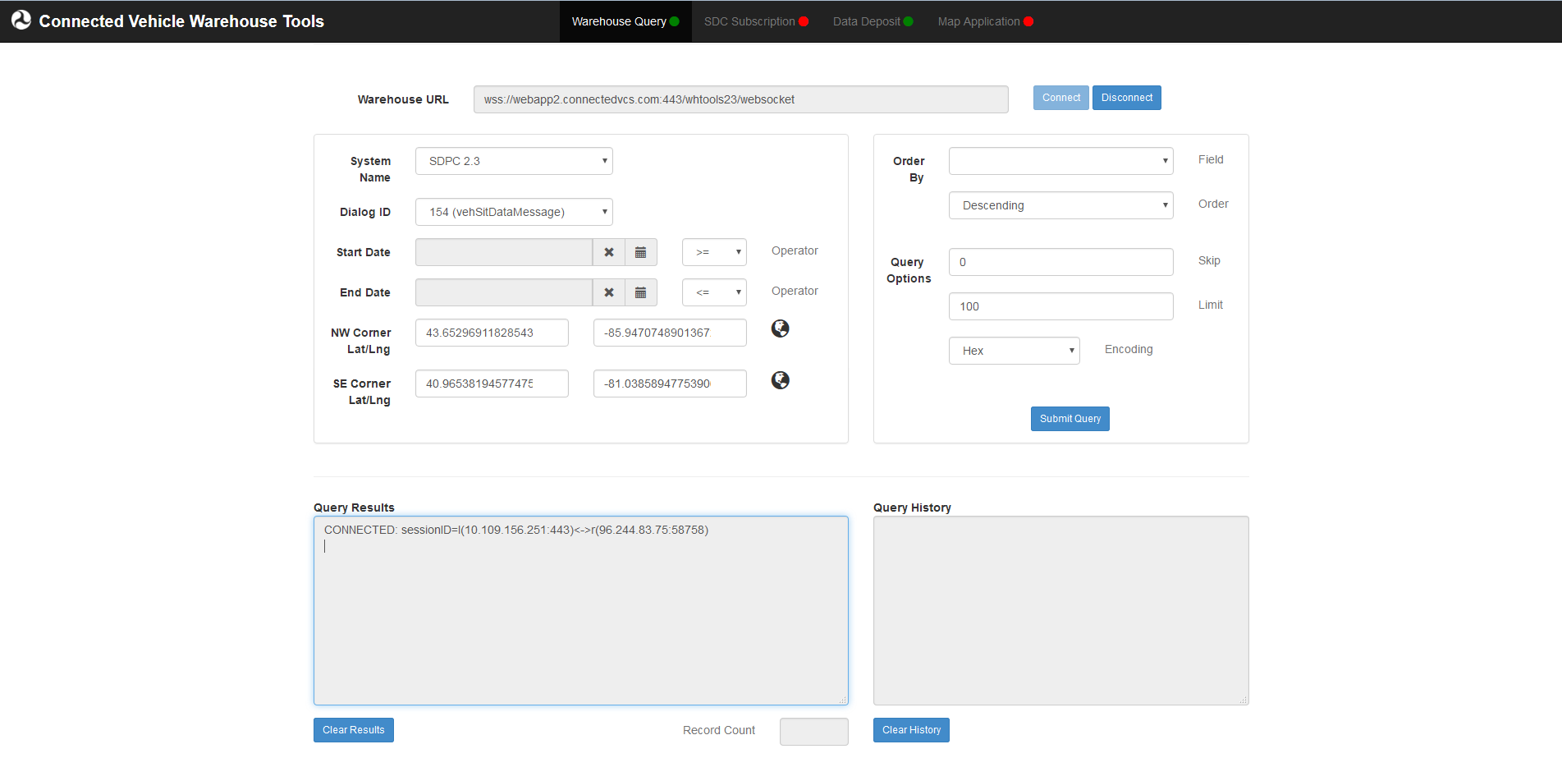

1. Define the query parameters.
   * Choose the system to run the query against, what type of messages to query for, specify a time range for the query, and define a bounding box for the area to search in.
   * Note that clicking the globe button next to the Lat/Lng selections will display a map allowing visual selection of latitude and longitude.
2. Define the query options.
   * Specify how many results the query should return, what encoding the results should be in, and the order of the results.
3. Click **Submit Query** to send the query to the warehouse.
   * The results will appear in the **Query Results** text area.
   * Note that although the cursor in all text areas is the prohibition sign **⃠** because the text areas are read-only, you can select the content of any text area and copy it via standard shortcut keys or a context menu available on the right click. The easiest way to copy all content from a text area is to click in the text area and then type Ctrl-A to select all lines and Ctrl-C to copy to clipboard.
   * The query that is sent to the Warehouse will be displayed in the **Query History** text area. This query can be used as direct input when using the Java Websocket Client.

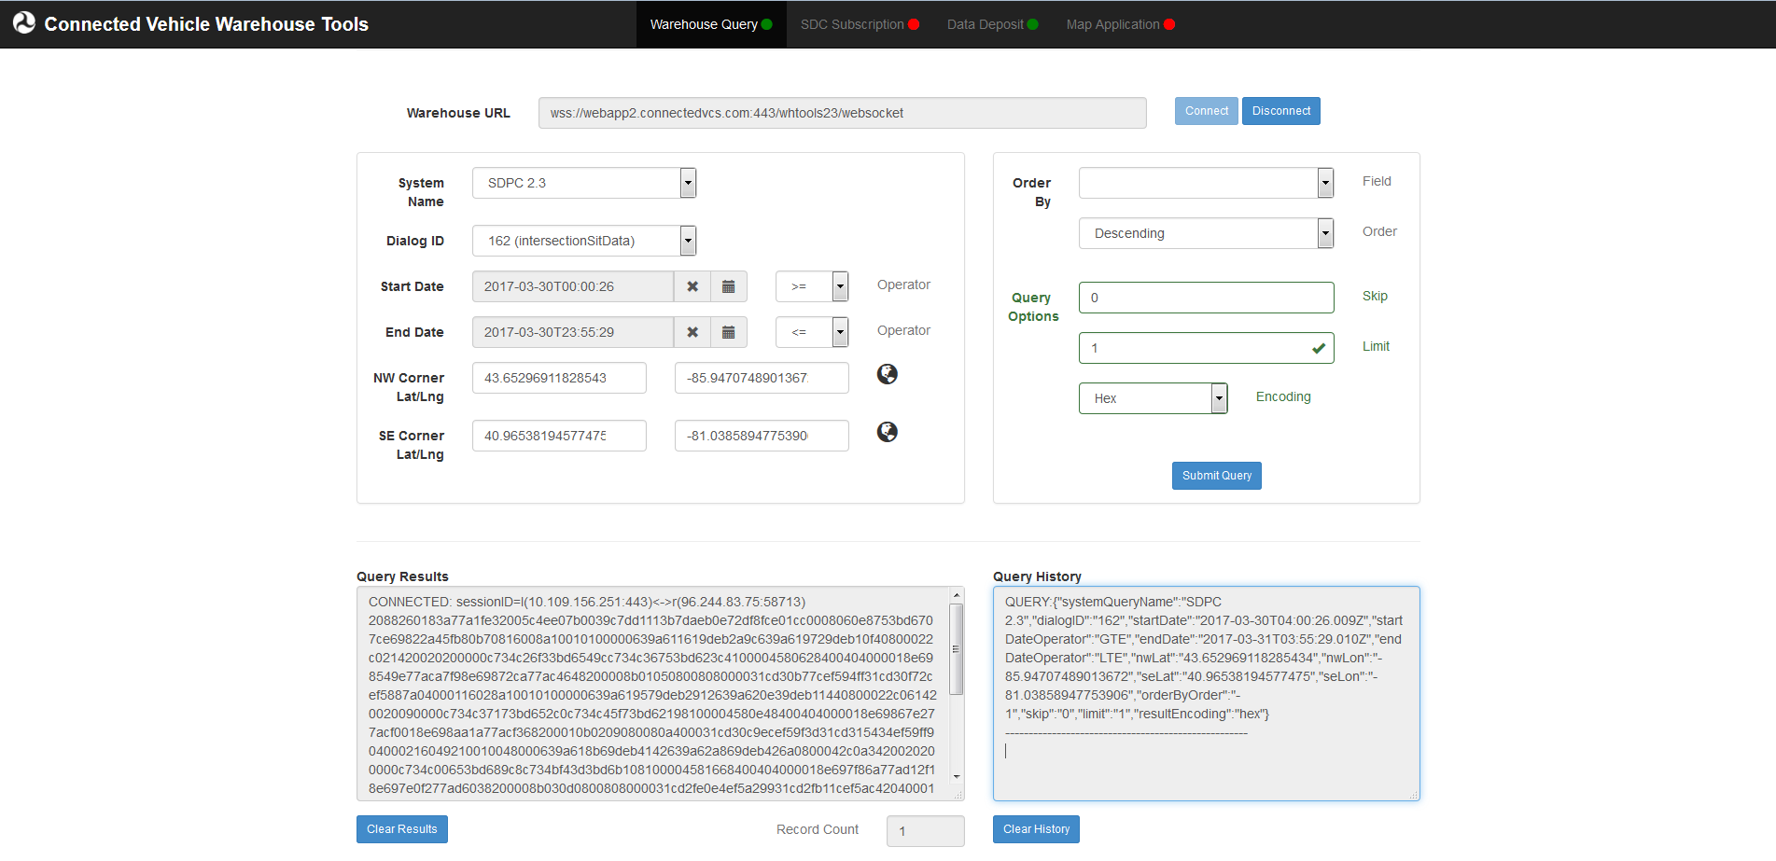

1. Repeat Steps 2 through 4 as desired.
2. To clear any text area, click the respective **Clear Results** button under the text area.
   * Note this will have no impact on the connection or queries: only on the text being displayed.

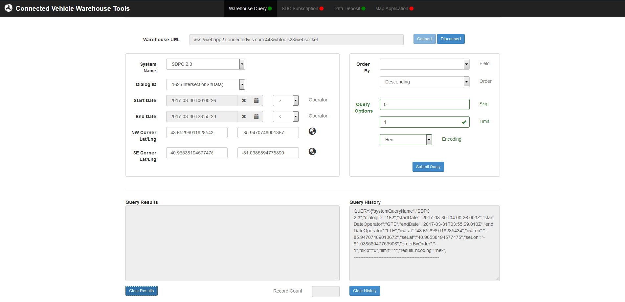

1. When done, click **Disconnect** to close the Warehouse connection.
   * Note, when the websocket is disconnected, the dot next to **Warehouse Query** in the navbar at the top will change to red.

**SDC Subscription**

1. Click **Connect** to create a connection to the Warehouse.
   * Note, when the websocket is connected, the dot next to **SDC Subscription** in the navbar at the top will change to green.

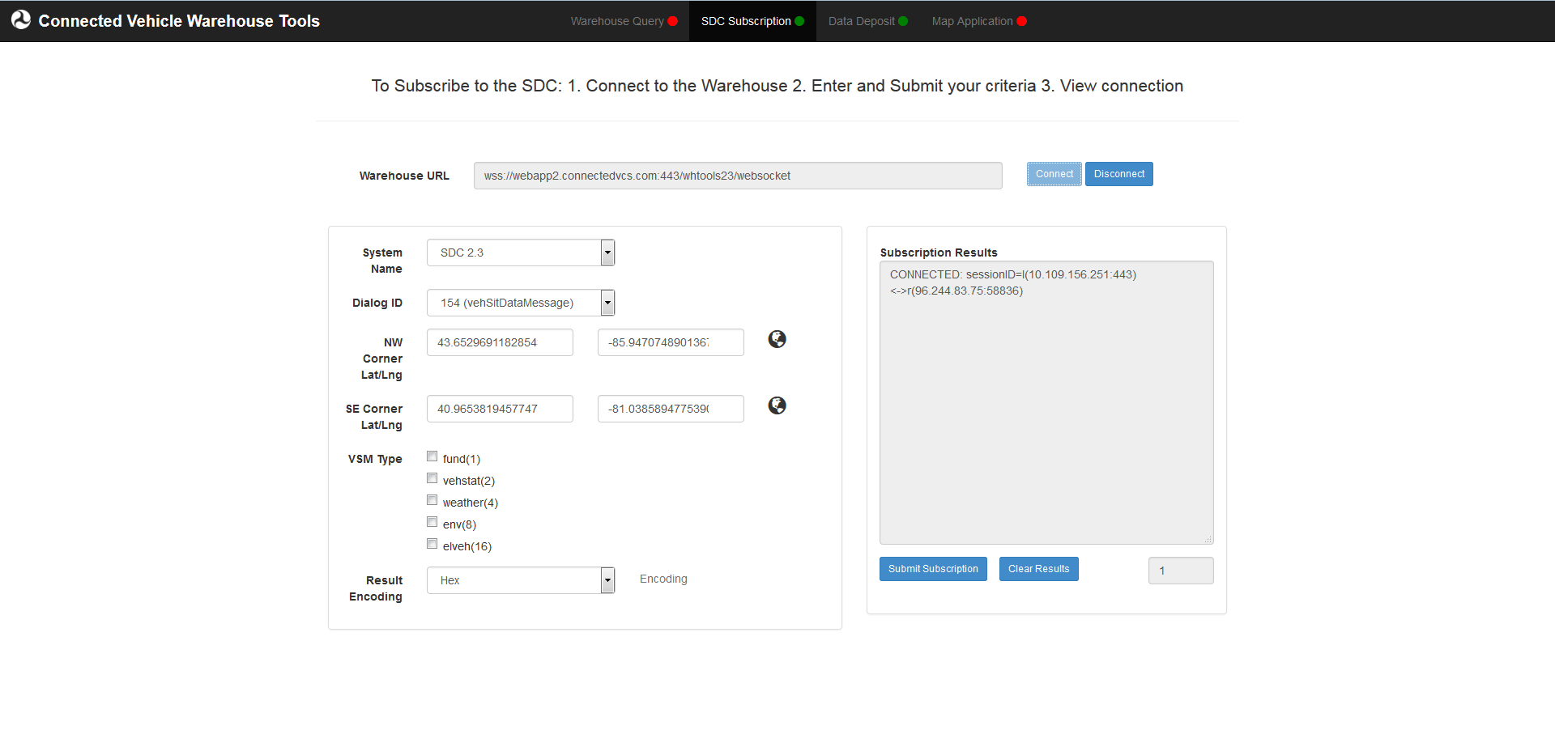

1. Define the subscription parameters.
   * Choose the system to run the query against, what type of messages to watch for, define the bounding box of the area to watch for messages, and choose the result encoding.
   * Note that clicking the globe button next to the Lat/Lng selections will display a map allowing visual selection of latitude and longitude.
2. Click **Submit Subscription** to open the subscription to the warehouse.
   * The results will appear in the **Subscription Results** text area.
   * Note that although the cursor in all text areas is the prohibition sign **⃠** because the text areas are read-only, you can select the content of any text area and copy it via standard shortcut keys or a context menu available on the right click. The easiest way to copy all content from a text area is to click in the text area and then type Ctrl-A to select all lines and Ctrl-C to copy to clipboard.
   * The SUBSCRIBE and START JSON that is sent to the Warehouse will also be displayed in the **Subscription Results** text area. These query can be used as direct input when using the Java Websocket Client.

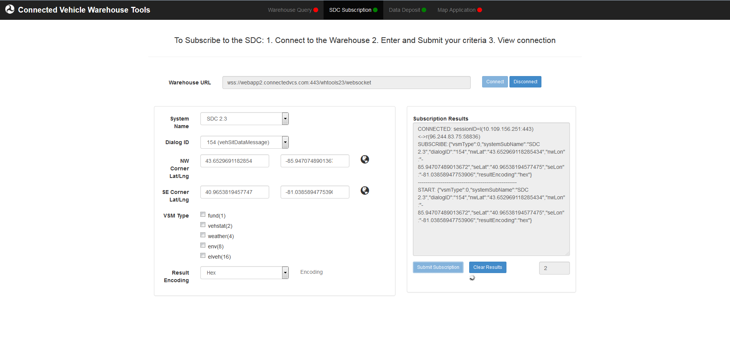

1. To stop the subscription, click **Disconnect**.
   * Note, when the websocket is disconnected, the dot next to **SDC Subscription** in the navbar at the top will change to red.
2. To clear the **Subscription Results**, click the **Clear Results** button at any time.
   * Note this will have no impact on the connection or subscription: only on the text being displayed.
3. For changes to the subscription parameters to take effect, the connection must be restarted (Steps 4 & 1) and the subscription resubmitted (Step 3).

**Data Deposit**

The dot next to **Data Deposit** in the navbar at the top must be green to deposit data. This should happen automatically when opening the Warehouse Tools, but if connection is lost it may turn red. If the dot is red, a page refresh is required to reset the websocket connection.

1. Select File Upload or Text Entry.
   1. If File Upload is selected, click **Browse…** to open the dialog to select the file from the system.
   2. If Text Entry is selected, enter the data to be deposited.
2. Choose the system in which the data will be deposited.
3. Choose the encoding format of the source data.

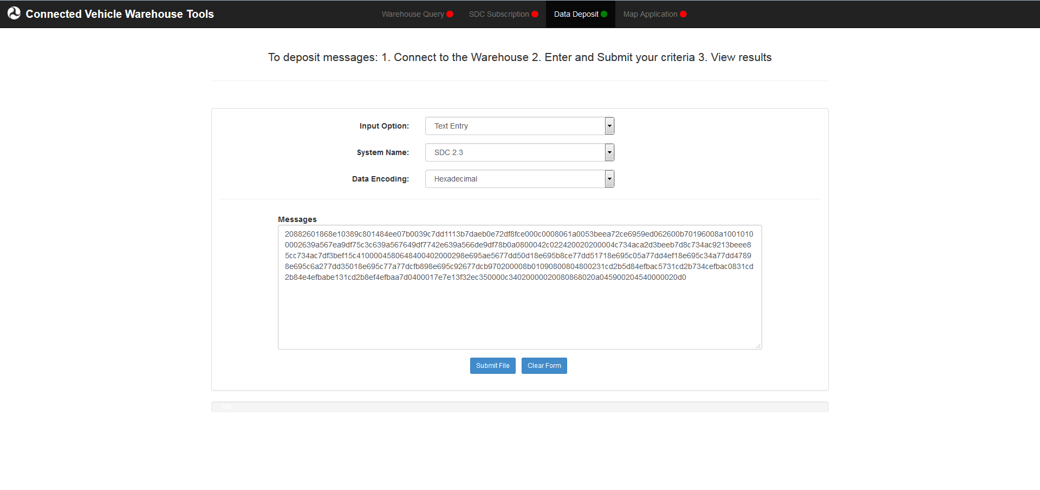

1. Click **Submit File** to deposit the data.

**Map Application**

To run the Map Application, select the **Map Tools** drop down box and then select **Start Application**. When the websocket is connected, the dot next to **Map Application** in the navbar at the top will change into a spinning gear.

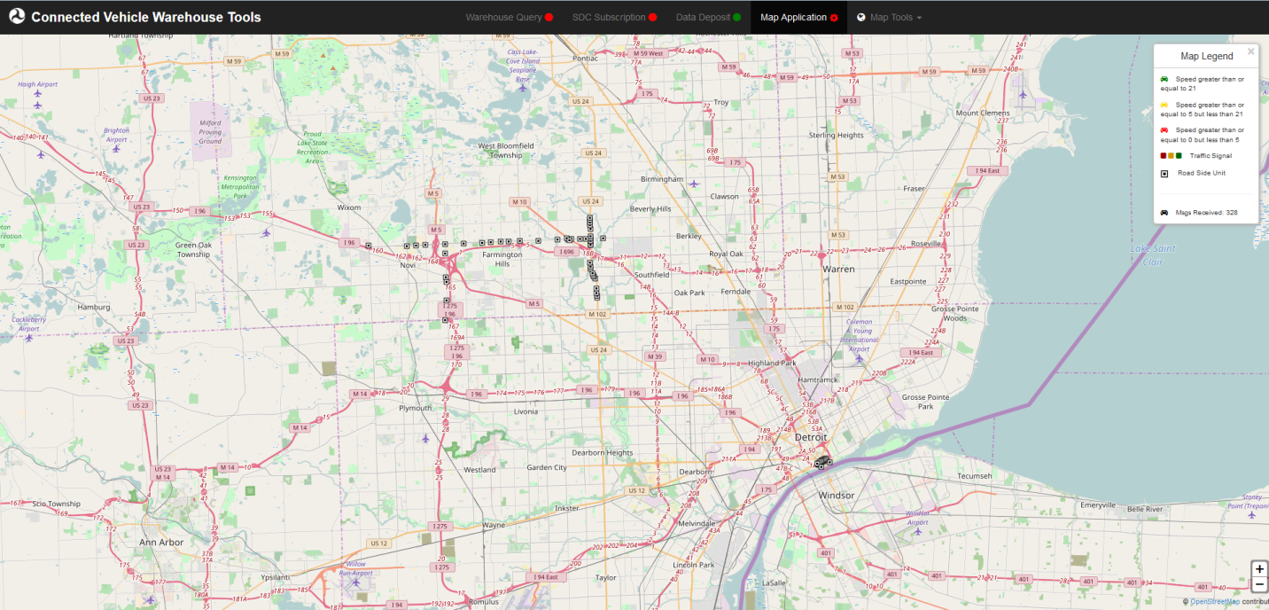

The Map will then begin to display information that is currently streaming to the systems. Some information, such as Traffic Signals, will require the map to be zoomed in to be displayed.

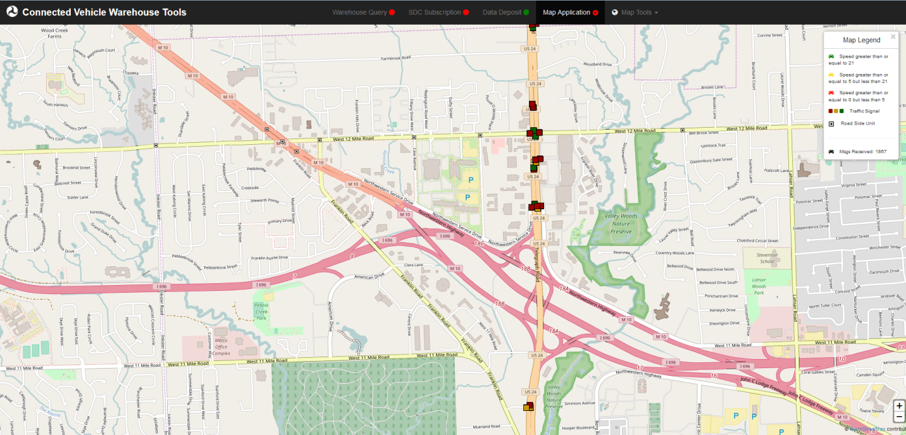

To stop the map, select **Stop Application** from the **Map Tools** drop down. When the websocket is disconnected, the spinning gear next to **Map Application** in the navbar at the top will return to dot.